St. Francis Institute of Technology, Mumbai-400 103

**Department of Information Technology**

A.Y. 2023-2024

Class: SE-ITA/B, Semester: IV

Subject: **UNIX LAB**

**Experiment – 6A:** Study of security tools and best practices in Linux (Ubuntu) operating system

**1. Aim:** To Study security tools and best practices in Linux (Ubuntu) operating system 2. **Objectives:** After study of this experiment, the student will be able to ● Understand what UNIX operating system is. 

● Identify the variants of various security tools in UNIX operating system. 3. **Outcomes:** After study of this experiment, the student will be able to ● Understand different security tools used in UNIX operating system. (L402.4) 4. **Prerequisite:** None.

5. **Requirements:** Personal Computer, Ubuntu 20.04 operating system, LibreOffice, Internet Connection.

**6. Laboratory Exercise**

**A. Procedure**

Introduction to security tools and best practices in Linux (Ubuntu) operating system Explore following tools : Snort, Nmap, Wireshark, CalmAV, OpenVAS, Nikto etc For above listed tools Elaborate on points such as

● Name of Tools

● features,

● user interface

● advantages,

● limitations (if any).

● screenshot of installation any one tool listed above

**B. Result/Observation**

Attach printout of above case study

**7. Post-Experiments Exercise**

**A. Extended Theory:**

Nil.

**B. Questions:**

1. Compare and contrast Wireshark , Nmap and Snort

**C. Conclusion:**

1. Write what was performed in the experiment.

2. Mention a few applications of what was studied.

3. Write the significance of the topic studied in the experiment.

**D. References:**

1. Sumitabha Das, UNIX Concepts and Applications, 3rd Ed., Tata McGraw Hill.

ELABORATING THE TOOLS:  **RIYA INDAP,44**

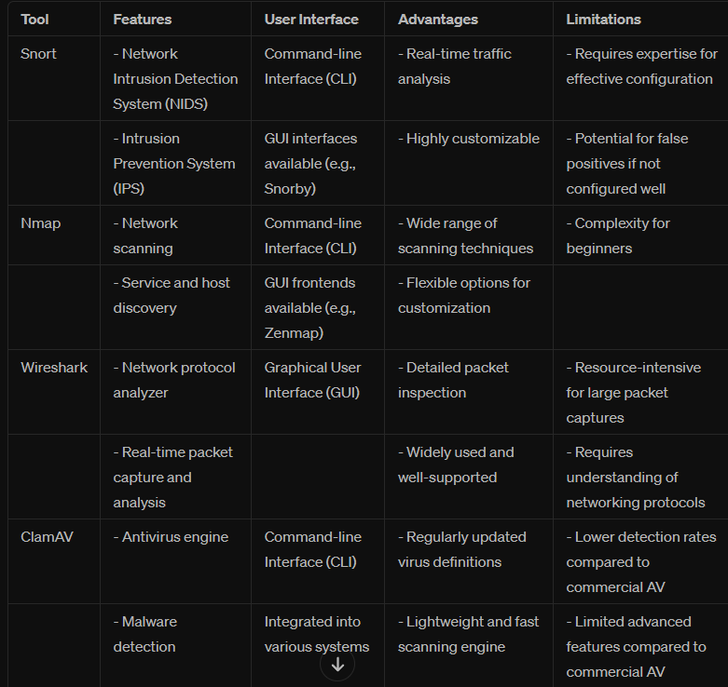

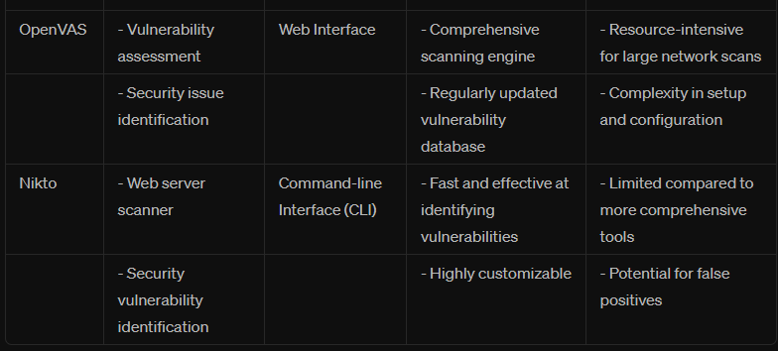

SNORT INSTALLATION:

Installing:

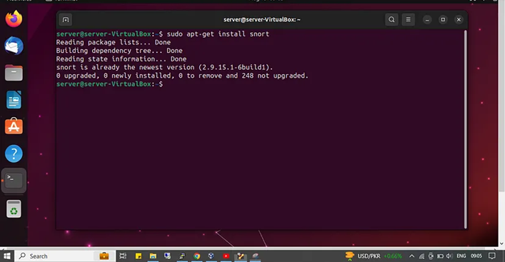

Configurations:

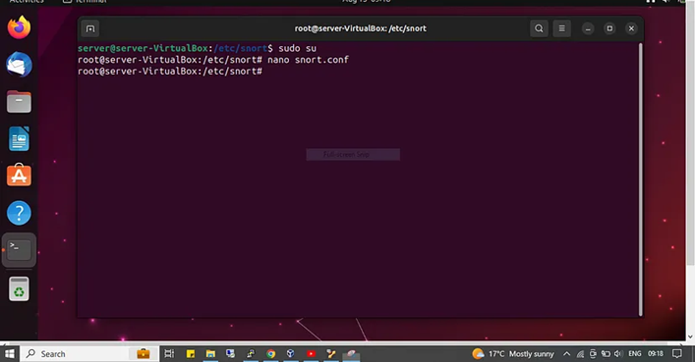

Ready to use:

